|  |  |
| --- | --- |
| Roll No. A026 | Name: Akshay Patil |
| Program: B-Tech (CSBS) | Division: - |
| Batch: B2 | Date of Experiment: 5/09/2020 |
| Date of Submission: 5/09/2020 | Grade: |

**Practical 7**

**(PART – A)**

***Aim: To develop a Turing machine.***

**Outcome:** After successfully competing of this practical, students will be able to learn:

* What is Turing machine?
* How it works?
* How to convert Turing machine to unrestricted grammar?

**A.1 Reading**

Read Page 70 to 102 of lab manual.

**A.2 Tasks**

1. Develop a single tape turing machine for the language L = {anbncn} for n > 0 using JFLAP tool.

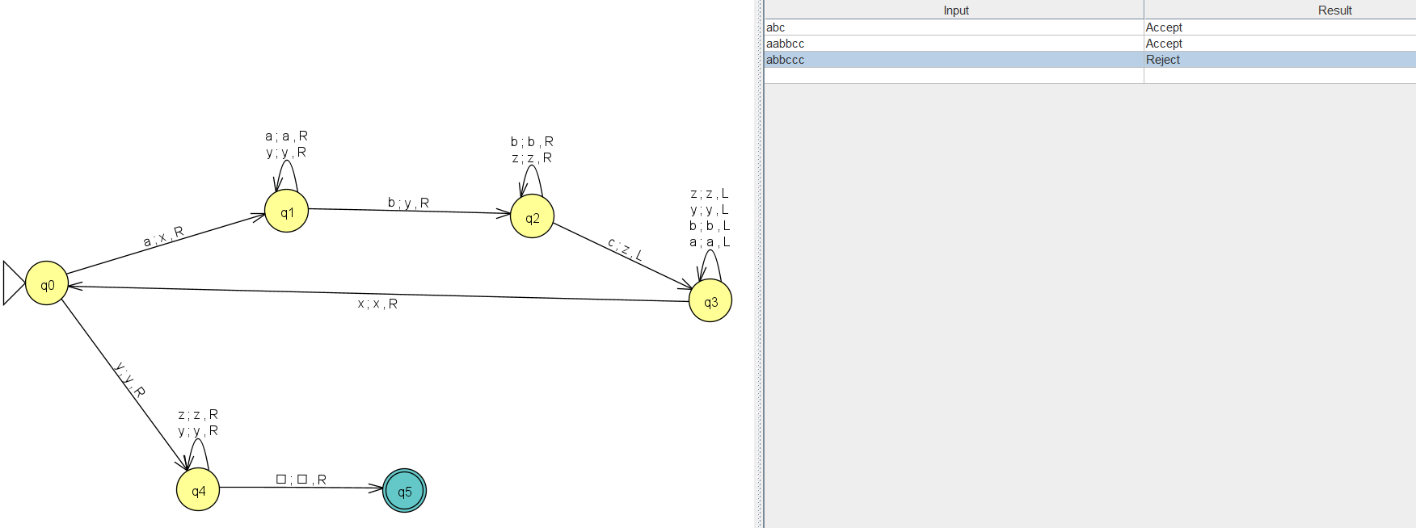

1. Convert it to unrestricted grammar using JFLAP tool.

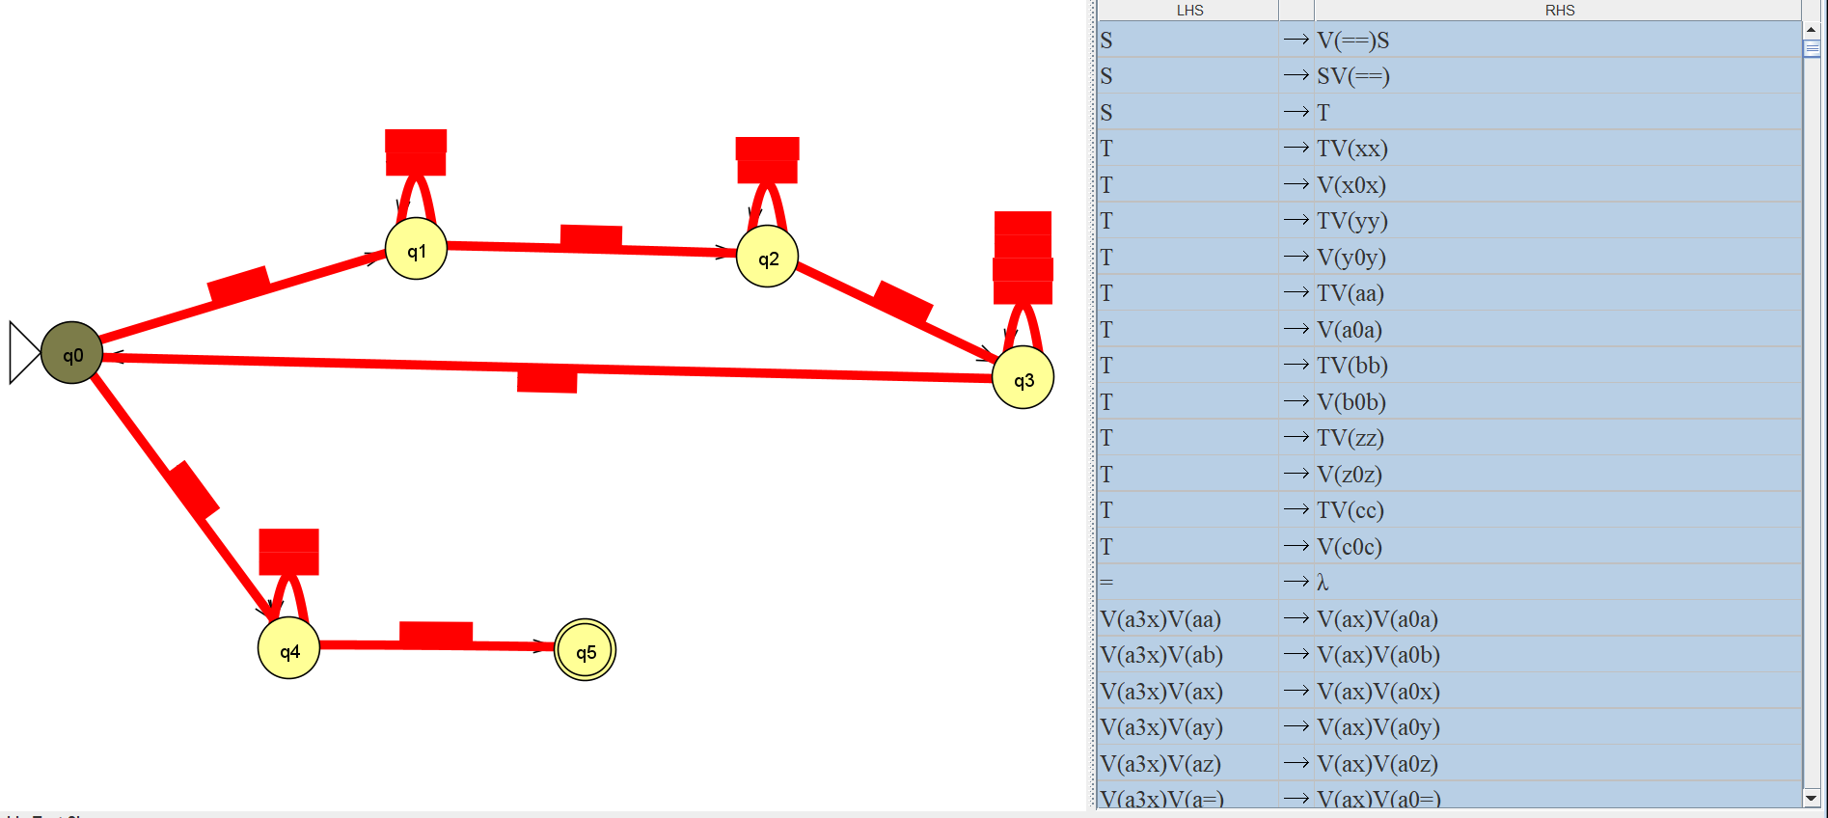

**PART B**

(PART B: TO BE COMPLETED BY STUDENTS)

**(Students must submit the soft copy as per following segments within two hours of the practical. The soft copy must be uploaded on the Portal or emailed to the concerned lab in charge faculties at the end of the practical in case the there is no portal access available)**

|  |  |
| --- | --- |
| Roll No. A026 | Name: Akshay Patil |
| Program: B-Tech (CSBS) | Division: |
| Batch: B2 | Date of Experiment: 5/09/2020 |
| Date of Submission: 5/09/2020 | Grade: |

**B.1 Output:**

1. Write a procedure to generate the Turing machine using JFLAP tool.

1. Open JFLAP tool and then click on Turing machine.
2. Create required number of states using state creator.
3. Create required transitions using transition creator.

2. Write a procedure to convert Turing machine to unrestricted grammar using the JFLAP tool.

1. Hover to the convert option.
2. Click on convert to unrestricted grammar.
3. Then click on show all.

**B.2 Observations/Learning**

We were able to design a Turing machine for the given language and successfully convert it to unrestricted grammar.

**B.3 Conclusion:**

The conclusion was derived from the experiment was that the Turing machine accepts the strings that contain equal number of a’s, b’s and c’s.